Full Stack Web Application
Project Documentation Format

1. Introduction
Project Title: FinWise AI - Intelligent Loan Eligibility, Credit Analysis & Financial Advisory Platform
Team Members & Roles:
Name | Role
Jainesh Bharti | Frontend Development + AI (Groq) Integration
Navneeth Biyyapu | Frontend Development + Google Sheets Integration
Vishnu Vardhana Reddy Paluvai | Frontend Development + UI/UX

2. Project Overview
Purpose: FinWise AI simplifies financial decision-making by letting users instantly check loan eligibility, analyze their credit score, calculate EMIs, and receive AI-generated personalised financial guidance - all in one responsive web app, with no signup required.
Key Features:
- Loan Eligibility Checker - rule-based validation against income, credit score, EMI and age thresholds
- Credit Score Analyzer - classifies profile into Excellent / Good / Poor with improvement tips
- EMI Calculator - standard reducing-balance EMI formula with amortisation summary
- AI Financial Tips - personalised recommendations generated via the Groq AI API
- Google Sheets Integration - every submission logged serverlessly via Google Apps Script
- Glassmorphism, mobile-responsive UI

3. Architecture
Frontend: Built with HTML5, CSS3 (glassmorphism styling, custom properties, responsive grid/flexbox) and vanilla JavaScript (ES6) - no framework is used, keeping the app lightweight and dependency-free.
Backend: There is no dedicated application server. Two lightweight services act as the backend: (1) the Groq AI Chat Completions API, called directly from the browser for financial-tip generation, and (2) a Google Apps Script Web App that exposes a doPost endpoint.
Database: Google Sheets is used as a serverless data store. Each user submission (inputs + computed result) is appended as a new row via the Apps Script webhook - there is no relational/NoSQL database.

4. Setup Instructions
Prerequisites: A modern web browser; a free Groq API key (from console.groq.com); optionally, a Google account to deploy your own Apps Script + Sheet.
Installation:
- Clone the repository: git clone https://github.com/JaineshBharti5/finwise-ai.git
- Open the folder and launch index.html directly in a browser, or serve it with any static server
- Enter your Groq API key under 'API Settings' in the sidebar to enable AI Financial Tips
- (Optional) Deploy google-apps-script.gs as a Web App in Google Apps Script and update the endpoint URL in the JS files to enable Sheets logging

5. Folder Structure
Path | Purpose
index.html | Landing page / dashboard
eligibility.html + js/eligibility.js | Loan Eligibility Checker page and logic
credit-score.html + js/credit-score.js | Credit Score Analyzer page and logic
emi.html + js/emi.js | EMI Calculator page and logic
tips.html + js/tips.js | AI Financial Tips page and Groq API integration
css/style.css | Shared glassmorphism stylesheet
js/app.js | Shared app-wide JavaScript (navigation, shared UI logic)
google-apps-script.gs | Serverless backend script for logging data to Google Sheets

6. Running the Application
As a fully static site, FinWise AI needs no build step or server process:
- Locally: open index.html directly in a browser, or run a simple static server (e.g. npx serve .)
- Production: served automatically via GitHub Pages at https://jaineshbharti5.github.io/finwise-ai

7. API Documentation
Endpoint | Method | Parameters | Example Response
Groq AI Chat Completions (api.groq.com) | POST | model, messages[] (user's financial profile as prompt), API key in header | JSON with an AI-generated financial-tips message
Google Apps Script Web App (script.google.com/macros/.../exec) | POST | JSON body: name, salary, credit score, EMI, age, result | JSON acknowledgement; new row appended to the linked Google Sheet

8. Authentication
FinWise AI does not implement user login/authentication - it is a stateless, no-signup tool. The only credential involved is the user-supplied Groq API key, entered client-side under API Settings and used solely to authorize AI Tips requests directly from the browser to Groq.

9. User Interface
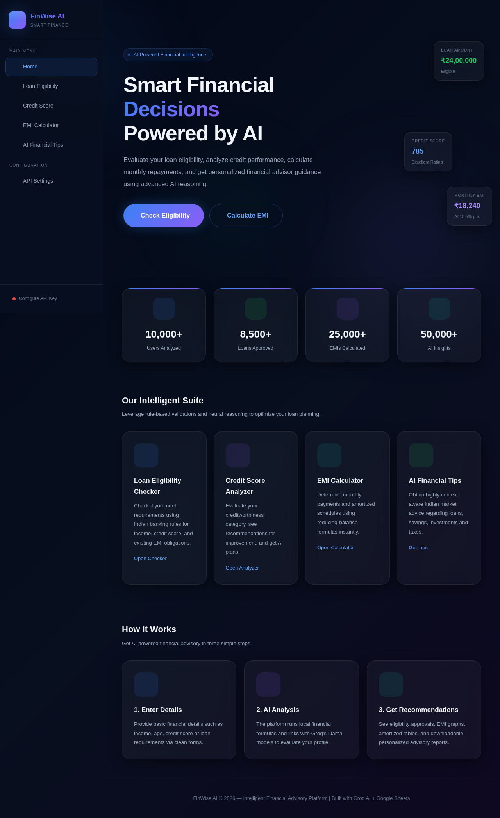
Figure: FinWise AI landing dashboard.

10. Testing
Testing combined manual functional testing of each rule engine (eligibility, credit score, EMI) against hand-calculated expected values, functional/performance testing of the Groq AI integration (response correctness and latency), and User Acceptance Testing (UAT) covering end-to-end scenarios across devices. See the Project Development Phase documents for full test case tables.

11. Screenshots / Demo
Live demo: https://jaineshbharti5.github.io/finwise-ai
Demo video: https://drive.google.com/file/d/1R7yStCQXAuEFCktQstJzgT8etC3Lp7Fr/view?usp=sharing
GitHub repository: https://github.com/JaineshBharti5/finwise-ai

12. Known Issues
- AI Financial Tips requires the user to supply their own free Groq API key; there is no shared/managed key.
- Google Sheets logging depends on the Apps Script Web App URL being correctly deployed and kept up to date in the frontend.
- No server-side validation - all checks are client-side, so the tool is best used for self-assessment, not as a system of record.

13. Future Enhancements
- User accounts to track eligibility/credit history over time
- A lightweight backend (Node.js/Express or serverless functions) to secure the Groq API key server-side
- Downloadable PDF summary of eligibility, credit and EMI results
- Multi-language support for wider accessibility
- Chatbot-style conversational interface for financial Q&A

